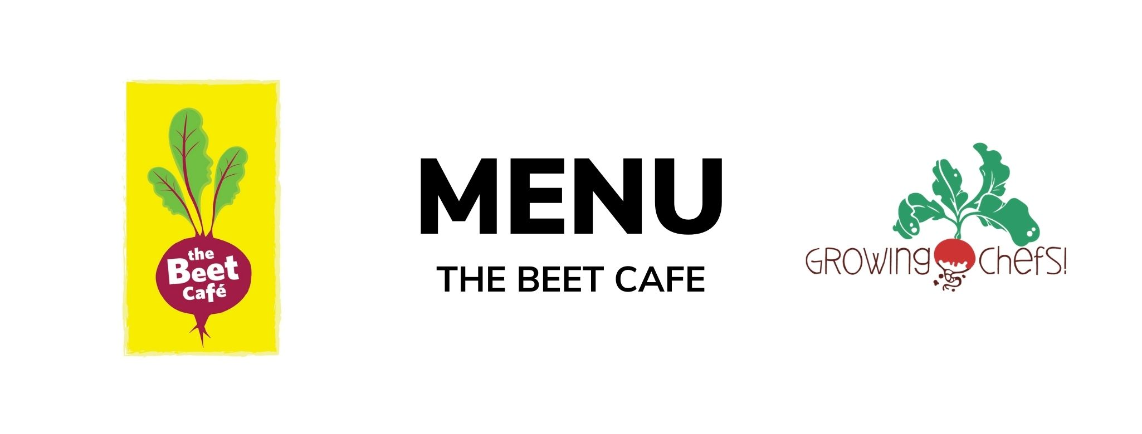

1  Holiday | 2  Beef Tacos/ Tortilla / Rice / Seasonal Veg / Fruit  Veg : Refried Beans Taco | 3  Coconut Crusted Cod / Potatoes/ Seasonal Veg / Fruit  Veg : Coconut Chickpea Curry | 4  Chicken Cheddar Sandwiches / Crudite with Ranch/ Fruit  Veg : Cocoa Sunbutter and Banana Sandwich (funky monkey) | 5  Chicken Shawarma/ Pita Bread/Romaine Salad / Baked Good  Veg : Falafel
8  Chickpea and Vegetable Tagine/Couscous  /Baked Good | 9  Beef Bolognese / Pasta / Caesar Salad / Fruit  Veg : Lentil Bolognese | 10  Turkey Burgers / Bun/ Crudite Vegetables/ Fruit  Veg : Meatless Burger  Our Munchkin:  Chick’n Nuggets / Potato Weges/ Crudite Vegetables/ Fruit | 11  Sweet and Sour Chicken/Rice/  Broccoli/Fruit  Veg:Sweet and Sour Tofu | 12  BBQ Chicken / Seasonal Vegetables / Mashed Potatoes/  Baked Good  Veg : BBQ Tofu Bites
15  Arepas/Black Beans and Sweet Potatoes/ Cucumbers/Baked Good | 16  Meatball With Marinara/Pasta/ Seasonal Vegetables/Fruit  Veg: Cauliflower Quinoa Meatballs | 17  Carrot Rice with Beef/Seasonal vegetables/ Fruit  Veg: Carrot Rice with Lentils | 18  Butter Chicken / Rice /Seasonal Vegetables/ Fruit  Veg : Chana Masala | 19  Chicken Alfredo / Penne / Italian Salad / Baked Good  Veg : White Bean Alfredo
22  Lemon Basil Rainbow Rotini/ Cucumbers/ Baked Good | 23  Beef Bulgogi/Rice/  Carrots and Cucumber/ Fruit  Veg: Tempeh Bulgogi | 24  Salmon/ Potato Wedges /Seasonal Veg / Fruit  Veg : Lentil Croquette | 25  Maple Mustard Chicken / Rice / Seasonal Veg / Fruit  Veg : Honey Mustard Tofu Fingers | 26  Chicken Chickpea Salad/Whole Wheat Bun/Crudite and Ranch/ Baked Good  Veg: Chickpea Salad
29  Vegetable Jambalaya/ Corn/ Baked Good | 30  Beef Sweet Potato Chili / Crispy Tostadas / Ranch Salad/ Fruit  Veg: Three Bean Chili | 1  Whole Wheat Roasted Chicken and Cheddar Wraps/ Crudite/ Fruit/  Veg : Whole Wheat Hummus, Cheddar and Vegetable Wraps | 2  Lemon Souvlaki Chicken/Pita/Greek Salad/Fruit  Veg: Paneer Lemon Souvlaki | 3  Chicken Adobo/ Rice / Pineapple and Cucumber/ Baked Good  Veg: Tempeh Adobo

