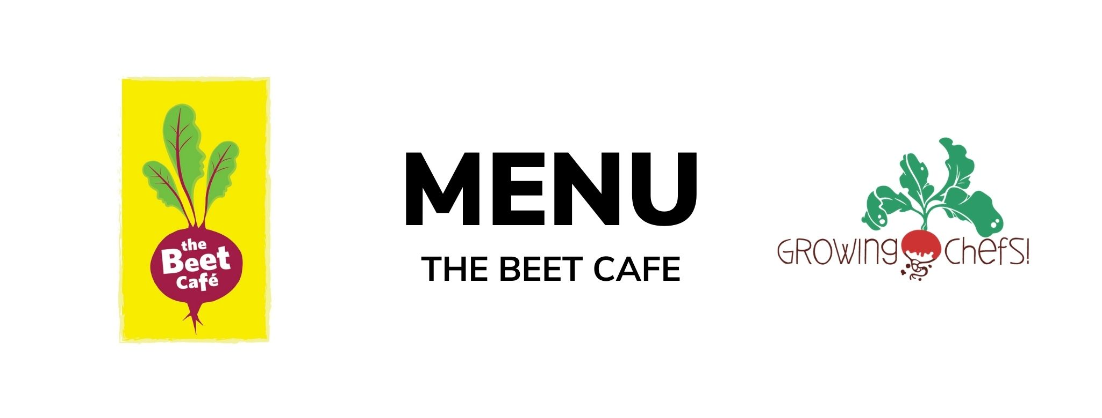

3  Minestrone Stew/ Garlic Toast/ Fruit | 4  Pancake and Sausage  Fruit  Potatoes  Veg : Veggie Sausage | 5  Chicken Shawarma/ Pita Bread/Romaine Salad / Baked Good  Veg : Falafel | 6  Focaccia Cheese Pizza/Crudite/ Greek Yogurt Dip/ Fruit | 7  Chicken Alfredo / Penne / Caesar Salad / Fruit  Veg : White Bean Alfredo
10  Butternut Mac & Cheese / Green Salad/ Seasonal Veg / Baked Good | 11  Beef Tacos/ Tortilla / Rice / Seasonal Veg / Fruit  Veg : Refried Beans Taco | 12  Chicken Tenders / Roasted Potatoes / Seasonal Veg / Baked Good  Veg: Tofu Tenders | 13  Turkey Cheddar Sandwiches / Crudite/ Fruit  Veg : Cocoa Sunbutter and Banana Sandwich (funky monkey) | 14  Coconut Crusted Cod / Rice/ Seasonal Veg / Fruit  Veg : Coconut Chickpea Potato Curry
17  Beef Bolognese / Pasta / Italian Salad / Baked Good  Veg : Lentil Bolognese | 18  Turkey Teriyaki/ Rice / Stir fry Vegetables / Fruit  Veg : Tofu Teriyaki | 19  Cheese and Egg Frittata/ Baked Potato Hash/ Seasonal Vegetables/ Baked Good | 20  Chicken Fajitas / Seasonal Veg/ Fruit/ Baked Good  Veg : Black Bean Fajitas | 21  BBQ Chicken / Crudite Vegetables / Mashed Potatoes/ Fruit  Veg : BBQ Tofu Bites
24  Cheese & Bean Enchiladas / Rice / Corn / Baked Good | 25  Chicken Parmesan / Noodles / Caesar salad / Baked Good  Veg : Tomato and Lentil Baked Pasta | 26  Turkey Burgers / Bun / Sweet Potato Fries /Crudite Vegetables/ Fruit  Veg : Meatless Burger | 27  Butter Chicken / Rice / Cucumbers/ Fruit  Veg : Chana Masala | 28  Salmon/ Rice /Seasonal Veg / Baked Good  Veg : Lentil Croquette
31  Vegetable Baked Penne/ Seasonal Vegetables /Baked Good | 1  Meatball With Marinara/Whole Wheat Bun/ Seasonal Vegetables/Fruit  Veg: Cauliflower Quinoa Meatballs | 2  Turkey Drumsticks / Mashed Potato / Romaine Salad/ Fruit  Veg : Lentil Loaf | 3  Turkey Sweet Potato Chili / Crispy Tostadas / Crudite/ Fruit  Veg: Three Bean Chili | 4  Honey Mustard Chicken / Rice / Seasonal Veg / Baked Good  Veg : Honey Mustard Tofu Fingers

