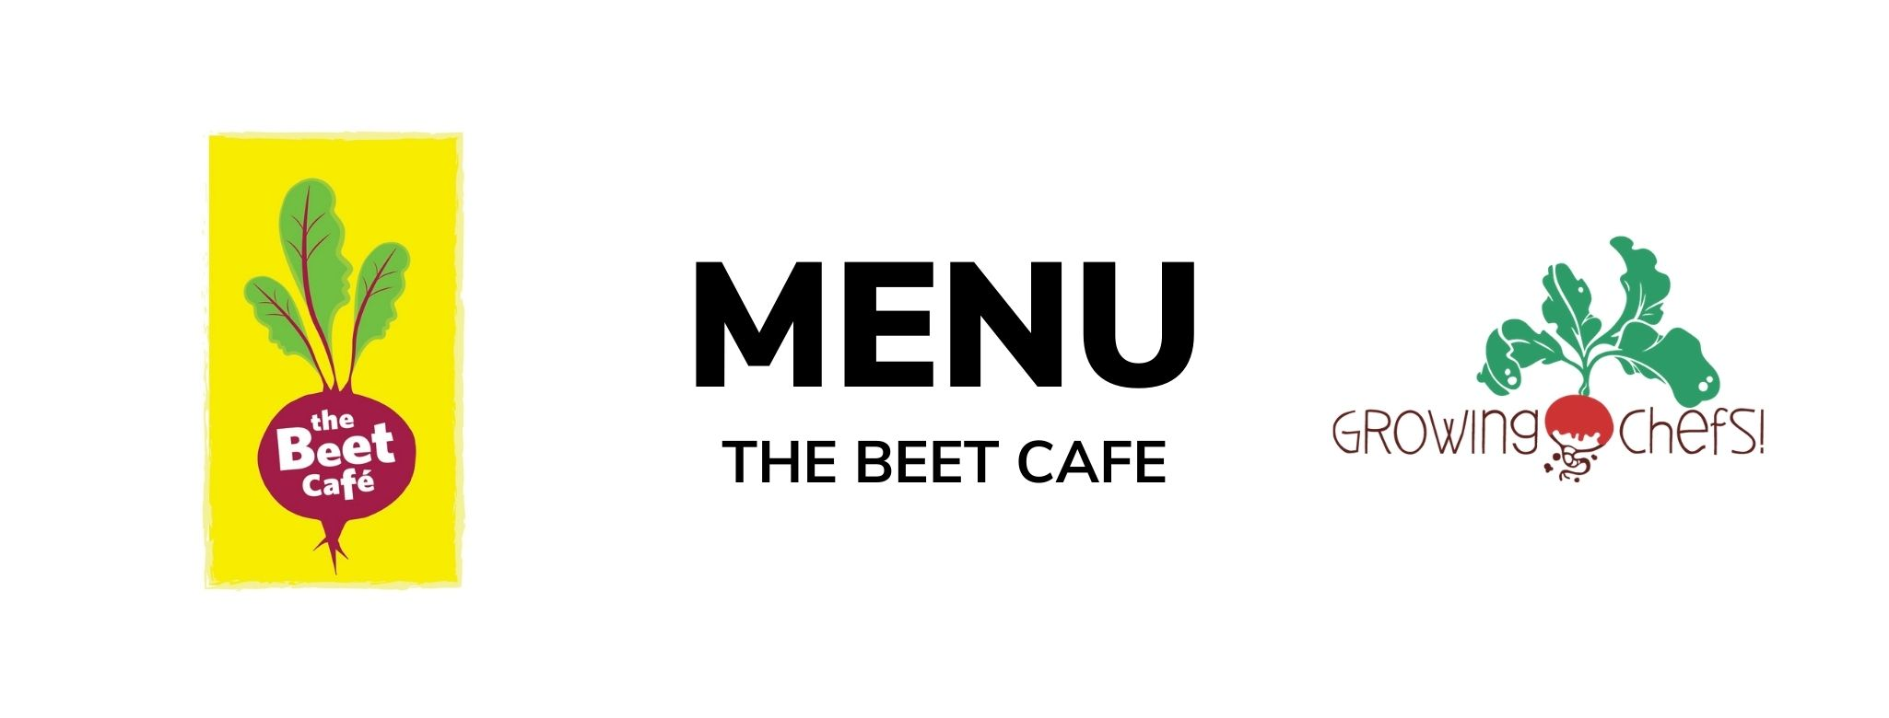

2  Cheese & Bean Enchiladas / Rice / Corn / Baked Good | 3  Chicken Parmesan / Noodles / Caesar Salad / Fruit  Veg : Tomato and Lentil Baked Pasta  *Lambeth requests cold menu, please make chicken rainbow pasta salad* | 4  Turkey Burgers / Bun / Sweet Potato Fries /Crudite Vegetables/ Fruit  Veg : Meatless Burger | 5  Butter Chicken / Rice / Cucumbers/ Fruit  Veg : Chana Masala | 6  Salmon/ Rice /Peas / Baked Good  Veg : Lentil Croquette
9  Vegetable Baked Penne/ Corn and Edamame /Baked Good | 10  Meatball With Marinara/Whole Wheat Bun/ Broccoli/Fruit  Veg: Cauliflower Quinoa Meatballs | 11  Turkey Drumsticks / Mashed Potato / Ranch Salad/ Fruit  Veg : Lentil Loaf | 12  Turkey Sweet Potato Chili / Crispy Tostadas / Crudite/ Fruit  Veg: Three Bean Chili | 13  Maple Mustard Chicken / Rice / Mixed Vegetables / Baked Good  Veg : Vegan Nuggets
16  Minestrone Stew/ Garlic Toast/ Fruit | 17  Beef Burgers / Bun / Crudite Vegetables / Baked Good  Veg : Veggie Burger  **Munchkin wants a hummus cheddar and vegetable wrap this day | 18  Chicken Shawarma/ Pita Bread/Romaine Salad / Baked Good  Veg : Falafel | 19  Focaccia Cheese Pizza/Crudite/ Greek Yogurt Dip/ Fruit | 20  Chicken Alfredo / Penne / Caesar Salad / Fruit  Veg : White Bean Alfredo
23  Butternut Mac & Cheese / Mixed Vegetables / Baked Good | 24  Beef Tacos/ Tortilla / Rice / Corn / Fruit  Veg : Refried Beans Taco | 25  Chicken Tenders / Roasted Potatoes / Seasonal Veg / Fruit  Veg: Vegan Tenders | 26  Roasted Chicken and Cheddar Sandwiches / Crudite / Baked Good  Veg : Cocoa Sunbutter and Banana Sandwich (funky monkey) | 27  Coconut Crusted Cod / Rice/ Peas/ Fruit  Veg : Coconut Chickpea Potato Curry

