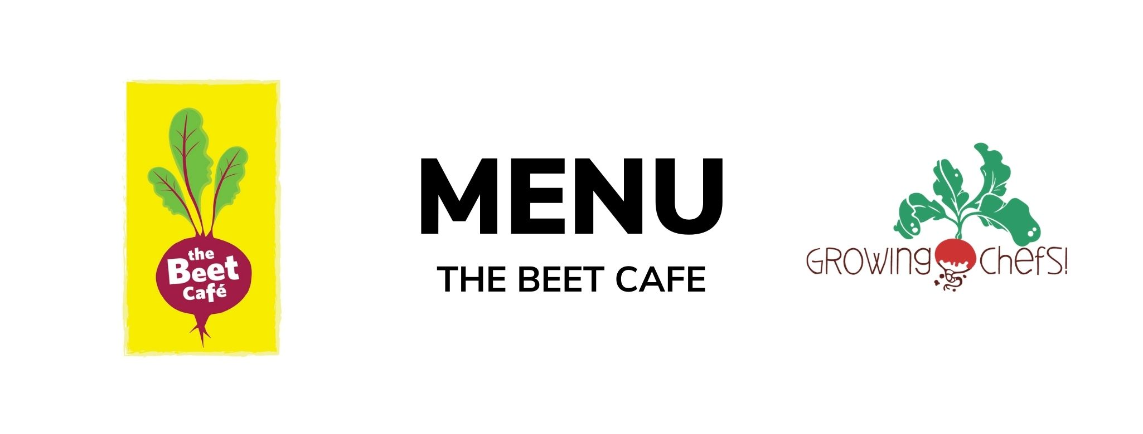

30 | 31 | 1 | 2  Special meal Ribambelle | 3  Special meal Ribambelle
6  Turkey Teriyaki/ Rice / Stir fry Vegetables /Baked Good  Veg : Tofu Teriyaki | 7  Beef Bolognese / Pasta / Italian Salad / Baked Good  Veg : Lentil Bolognese | 8  Cheese and Egg Frittata/ Baked Potato Hash/ Seasonal Vegetables/ Fruit | 9  Chicken Fajitas / Seasonal Veg/ Fruit/ Baked Good  Veg : Black Bean Fajitas | 10  BBQ Chicken / Crudite Vegetables / Mashed Potatoes/ Fruit  Veg : BBQ Tofu Bites
13  Cheese & Bean Enchiladas/ Rice / Corn / Baked Good | 14  Chicken Parmesan / Noodles / Seasonal Veg / Baked Good  Veg : Tomato and Lentil Baked Pasta | 15  Turkey Burgers / Bun / Sweet Potato Fries /Crudite Vegetables/ Baked Good  Veg : Meatless Burger | 16  Butter Chicken / Rice / Cucumbers/ Fruit  Veg : Chana Masala | 17  Salmon/ Rice /Seasonal Veg / Baked Good  Veg : Lentil Croquette
20  Vegetable Baked Penne/ Romaine Salad/Baked Good | 21  Meatball with marinara/whole wheat bun/ Seasonal Vegetables/Fruit  Veg: Cauliflower Quinoa meatballs | 22  Turkey Drumsticks / Mashed Potato / Romaine Salad/ Fruit  Veg : Lentil Loaf | 23  Focaccia Pizza/Crudite Veg/Greek Yogurt Dip/Fruit | 24  Honey Mustard Chicken / Rice / Seasonal Veg / Baked Good  Veg : Honey Mustard Tofu Fingers
27  Minestrone Stew/ Garlic Toast/ Fruit | 28  Chicken Shawarma/ Pita Bread/Romaine Salad / Fruit  Veg : Falafel | 29  Turkey Sweet Potato Chili / Crispy Tostadas / Crudite/ Fruit  Veg: Three Bean Chili | 30  Beef Burgers / Bun / Seasonal Veg / Baked Good  Veg : Veggie Burger | 1  Chicken Alfredo / Penne / Caesar Salad / Fruit  Veg : White Bean Alfredo

