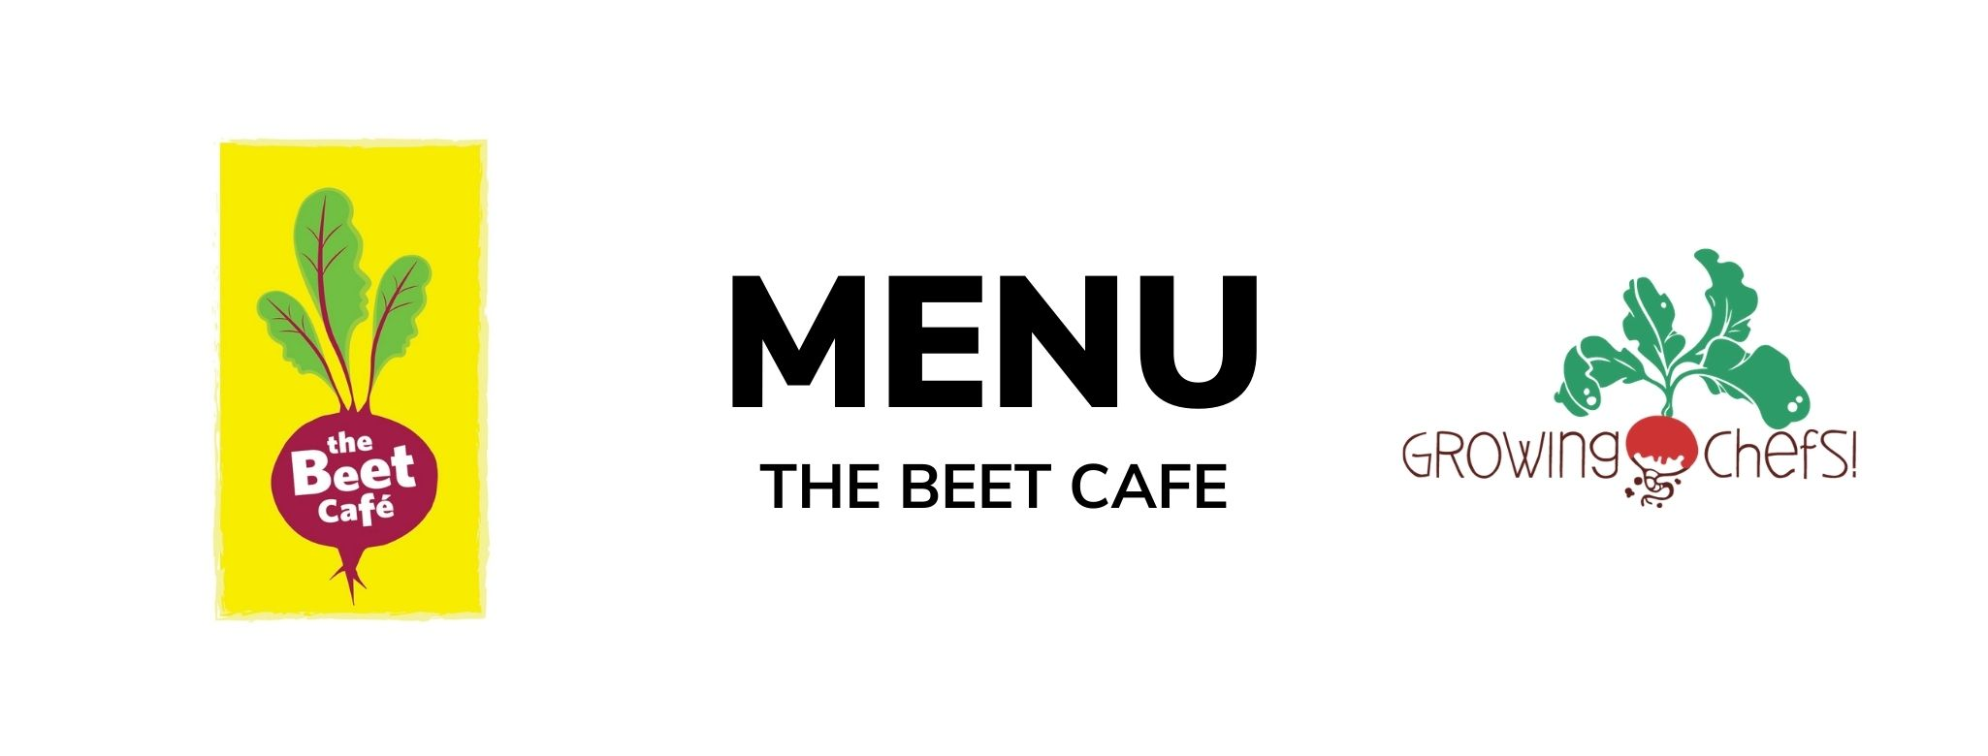

3  Butternut Mac & Cheese / Green Salad/ Seasonal Veg / Baked Good | 4  Beef Tacos/ Tortilla / Rice / Seasonal Veg / Fruit  Veg : Refried Beans Taco | 5  Chicken Tenders / Roasted Potatoes / Seasonal Veg / Baked Good  Veg: Tofu Tenders | 6  Turkey Cheddar Sandwiches / Crudite/ Fruit  Veg : Cocoa Sunbutter and Banana Sandwich (funky monkey) | 7  Coconut Crusted Cod / Rice/ Seasonal Veg / Fruit  Veg : Coconut Chickpea Potato Curry
10  Beef Bolognese / Pasta / Italian Salad / Baked Good  Veg : Lentil Bolognese | 11  Turkey Teriyaki/ Rice / Stir fry Vegetables / Fruit  Veg : Tofu Teriyaki | 12  Cheese and Egg Frittata/ Baked Potato Hash/ Seasonal Vegetables/ Baked Good | 13  Chicken Fajitas / Seasonal Veg/ Fruit/ Baked Good  Veg : Black Bean Fajitas | 14  BBQ Chicken / Crudite Vegetables / Mashed Potatoes/ Fruit  Veg : BBQ Tofu Bites
17  Family Day | 18  Chicken Parmesan / Noodles / Caesar salad / Baked Good  Veg : Tomato and Lentil Baked Pasta | 19  Turkey Burgers / Bun / Sweet Potato Fries /Crudite Vegetables/ Fruit  Veg : Meatless Burger | 20  Butter Chicken / Rice / Cucumbers/ Fruit  Veg : Chana Masala | 21  Salmon/ Rice /Seasonal Veg / Baked Good  Veg : Lentil Croquette
24  Vegetable Baked Penne/ Seasonal Vegetables /Baked Good | 25  Meatball With Marinara/Whole Wheat Bun/ Seasonal Vegetables/Fruit  Veg: Cauliflower Quinoa Meatballs | 26  Turkey Drumsticks / Mashed Potato / Romaine Salad/ Fruit  Veg : Lentil Loaf | 27  Turkey Sweet Potato Chili / Crispy Tostadas / Crudite/ Fruit  Veg: Three Bean Chili | 28  Honey Mustard Chicken / Rice / Seasonal Veg / Baked Good  Veg : Honey Mustard Tofu Fingers

