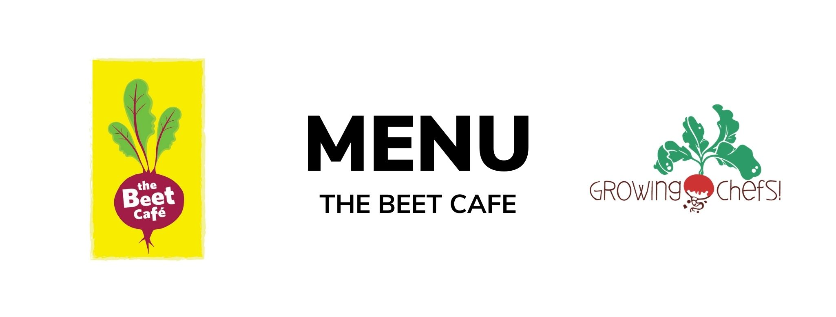

7  Minestrone Stew/ Garlic Toast/ Fruit | 8  Beef Burgers / Bun / Seasonal Veg / Baked Good  Veg : Veggie Burger | 9  Chicken Shawarma/ Pita Bread/Romaine Salad / Baked Good  Veg : Falafel | 10  Focaccia Cheese Pizza/Crudite/ Greek Yogurt Dip/ Fruit | 11  Chicken Alfredo / Penne / Caesar Salad / Fruit  Veg : White Bean Alfredo
14  Butternut Mac & Cheese / Green Salad/ Seasonal Veg / Baked Good | 15  Beef Tacos/ Tortilla / Rice / Seasonal Veg / Fruit  Veg : Refried Beans Taco | 16  Chicken Tenders / Roasted Potatoes / Seasonal Veg / Baked Good  Veg: Tofu Tenders | 17  Turkey Cheddar Sandwiches / Crudite/ Fruit  Veg : Cocoa Sunbutter and Banana Sandwich (funky monkey) | 18  Good Friday
21  Easter Monday | 22  Turkey Teriyaki/ Rice / Stir fry Vegetables / Fruit  Veg : Tofu Teriyaki | 23  Cheese and Egg Frittata/ Baked Potato Hash/ Seasonal Vegetables/ Baked Good | 24  Chicken Fajitas / Seasonal Veg/ Fruit/ Baked Good  Veg : Black Bean Fajitas | 25  BBQ Chicken / Crudite Vegetables / Mashed Potatoes/ Fruit  Veg : BBQ Tofu Bites
28  Cheese & Bean Enchiladas / Rice / Corn / Baked Good | 29  Chicken Parmesan / Noodles / Caesar salad / Baked Good  Veg : Tomato and Lentil Baked Pasta | 30  Turkey Burgers / Bun / Sweet Potato Fries /Crudite Vegetables/ Fruit  Veg : Meatless Burger | 1  Butter Chicken / Rice / Cucumbers/ Fruit  Veg : Chana Masala | 2  Salmon/ Rice /Seasonal Veg / Baked Good  Veg : Lentil Croquette

