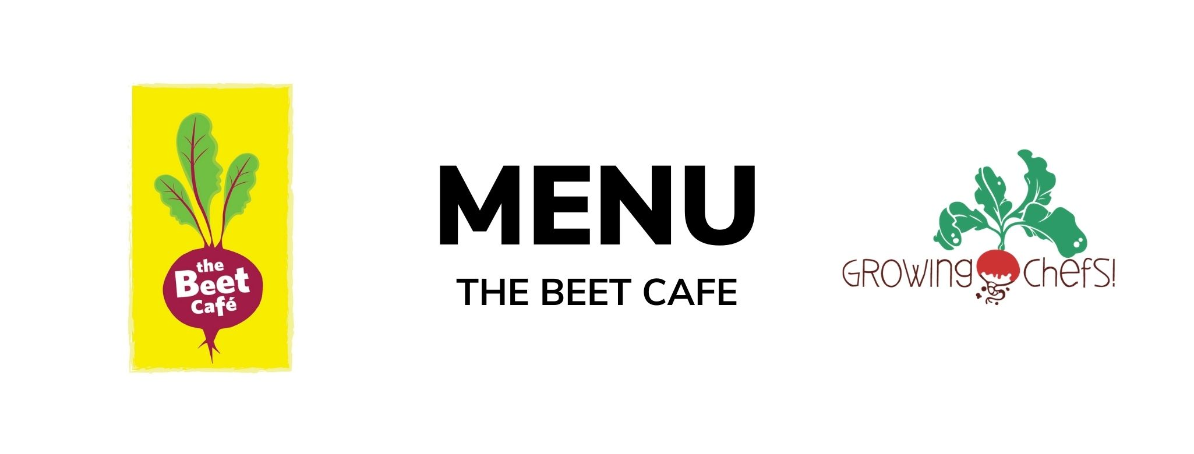
December 2023

4  Butternut Mac & Cheese / Green Salad/ Seasonal Veg / Baked Good | 5  Chicken Shawarma/ Pita Bread/Romaine Salad / Fruit  Veg : Falafel | 6  Beef Burgers / Bun / Seasonal Veg / Baked Good  Veg : Veggie Burger | 7  Butter Chicken / Rice / Cucumbers/ Fruit  Veg : Butter Tofu | 8  Chicken Parmesan / Egg Noodles / Seasonal Veg / Baked Good  Veg : Eggplant Parmesan
11  Three Bean Chili / Cornbread / Seasonal Veg / Baked Good | 12  Beef Tacos/ Tortilla / Rice / Seasonal Veg / Fruit  Veg : Refried Beans Taco | 13  Turkey Shepherd's Pie / Seasonal Veg / Fruit  Veg : Lentil Shepherds Pie | 14  Chicken Pot Pie / Kale Caesar / Baked Good  Veg : White Bean Pot Pie | 15  Coconut Crusted Cod / Roasted Potatoes / Seasonal Veg / Fruit  Veg : Coconut Tofu
18  Cheese & Bean Quesadilla / Rice / Seasonal Veg/ Baked Good | 19  Beef Bolognese / Pasta / Green Salad / Baked Good  Veg : Lentil Bolognese | 20  Hot Turkey Sandwiches / Bun / Seasonal Veg / Fruit  Veg : Meatless Patty | 21  BBQ Chicken / Seasonal Veg / Potato/ Fruit  Veg : BBQ Tofu | 22  Chicken Fusilli/  Seasonal Veg/ Baked Good  Veg : Vegetable Lasagna

